**Exercise 7: Financial Forecasting**

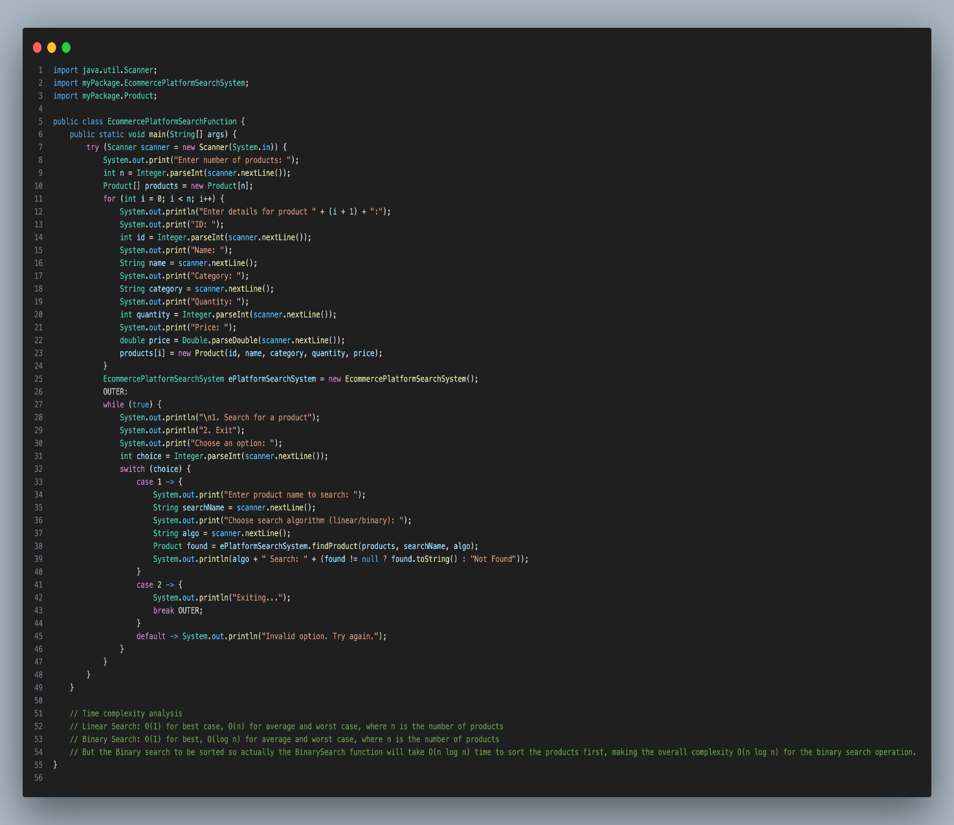

Output

